**Exercise 1: Configuring a Basic Spring Application**

**Exercise 2: Implementing Dependency Injection**

**pom.xml**

<project xmlns="http://maven.apache.org/POM/4.0.0" xmlns:xsi="http://www.w3.org/2001/XMLSchema-instance" xsi:schemaLocation="http://maven.apache.org/POM/4.0.0 http://maven.apache.org/xsd/maven-4.0.0.xsd">

<modelVersion>4.0.0</modelVersion>

<groupId>com.library</groupId>

<artifactId>LibraryManagements</artifactId>

<version>0.0.1-SNAPSHOT</version>

<dependencies>

<dependency>

<groupId>org.springframework</groupId>

<artifactId>spring-context</artifactId>

<version>5.3.30</version>

</dependency>

</dependencies>

</project>

**applicationContext.xml**

<?**xml** version=*"1.0"* encoding=*"UTF-8"*?>

<**beans** xmlns=*"http://www.springframework.org/schema/beans"*

xmlns:xsi=*"http://www.w3.org/2001/XMLSchema-instance"*

xsi:schemaLocation=*"*

*http://www.springframework.org/schema/beans*

*http://www.springframework.org/schema/beans/spring-beans.xsd"*>

<!-- Repository Bean -->

<**bean** id=*"bookRepository"* class=*"com.library.repository.BookRepository"*/>

<!-- Service Bean with dependency injection -->

<**bean** id=*"bookService"* class=*"com.library.service.BookService"*>

<**property** name=*"bookRepository"* ref=*"bookRepository"*/>

</**bean**>

</**beans**>

**BookRepository.java**

package com.library.repository;

public class BookRepository {

public void saveBook(String bookName) {

System.***out***.println("Saving book: " + bookName);

}

}

**BookService.java**

package com.library.service;

import com.library.repository.BookRepository;

public class BookService {

private BookRepository bookRepository;

// Setter for Dependency Injection

public void setBookRepository(BookRepository bookRepository) {

this.bookRepository = bookRepository;

}

public void addBook(String bookName) {

System.***out***.println("Adding book: " + bookName);

bookRepository.saveBook(bookName);

}

}

**MainApp.java**

package com.librarys;

import com.library.service.BookService;

import org.springframework.context.ApplicationContext;

import org.springframework.context.support.ClassPathXmlApplicationContext;

public class MainApp {

public static void main(String[] args) {

ApplicationContext context = new ClassPathXmlApplicationContext("applicationContext.xml");

BookService bookService = (BookService) context.getBean("bookService");

bookService.addBook("Spring in Action");

}

}

**Output**

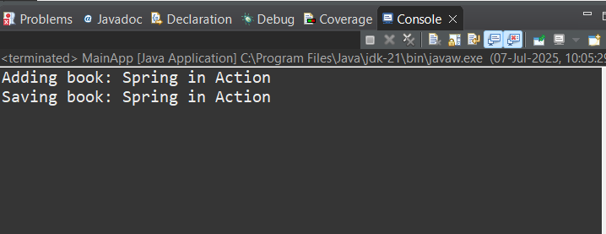

**Exercise 4: Creating and Configuring a Maven Project**

**pom.xml**

<project xmlns="http://maven.apache.org/POM/4.0.0" xmlns:xsi="http://www.w3.org/2001/XMLSchema-instance" xsi:schemaLocation="http://maven.apache.org/POM/4.0.0 https://maven.apache.org/xsd/maven-4.0.0.xsd">

<modelVersion>4.0.0</modelVersion>

<groupId>com.library</groupId>

<artifactId>Library_Management</artifactId>

<version>0.0.1-SNAPSHOT</version>

<dependencies>

<!-- Spring Context -->

<dependency>

<groupId>org.springframework</groupId>

<artifactId>spring-context</artifactId>

<version>5.3.30</version>

</dependency>

<!-- Spring AOP -->

<dependency>

<groupId>org.springframework</groupId>

<artifactId>spring-aop</artifactId>

<version>5.3.30</version>

</dependency>

<!-- Spring Web MVC -->

<dependency>

<groupId>org.springframework</groupId>

<artifactId>spring-webmvc</artifactId>

<version>5.3.30</version>

</dependency>

</dependencies>

<build>

<plugins>

<!-- Maven Compiler Plugin -->

<plugin>

<groupId>org.apache.maven.plugins</groupId>

<artifactId>maven-compiler-plugin</artifactId>

<version>3.8.1</version>

<configuration>

<source>1.8</source>

<target>1.8</target>

</configuration>

</plugin>

</plugins>

</build>

</project>

**Output**

